Aditya Patel

APUSH

Period 4

11/20/2020

Board Game Group 3 Aditya Patel Primary Sources

**Herbert Spencer**

Herbert Spencer, Social Statics

“The poverty of the incapable, the distresses that come upon the imprudent, the starvation of the idle, and those shoulderings aside of the weak by the strong, which leave so many "in shallows and in miseries," are the decrees of a large, farseeing benevolence. It seems hard that an unskilfulness which with all its efforts he cannot overcome, should entail hunger upon the artisan. It seems hard that a labourer incapacitated by sickness from competing with his stronger fellows, should have to bear the resulting privations…Nevertheless, when regarded not separately, but in connection with the interests of universal humanity, these harsh fatalities are seen to be full of the highest beneficence--the same beneficence which brings to early graves the children of diseased parents, and singles out the low-spirited, the intemperate, and the debilitated as the victims of an epidemic.”

**William Graham Sumner**

William Graham Sumner, The Challenge of Facts and Other Essays (ca.1880s)  
“Nature is entirely neutral; she submits to him who most energetically and resolutely assails her. She grants her rewards to the fittest, therefore, without regard to other considerations of any kind. If, then, there be liberty, men get from her just in proportion to their works, and their having and enjoying are just in proportion to their being and their doing. Such is the system of nature. If we do not like it, and if we try to amend it, there is only one way in which we can do it. We can take from the better and give to the worse… We shall thus lessen the inequalities. We shall favor the survival of the unfittest, and we shall accomplish this by destroying liberty… The former carries society forward and favors all its best members; the latter carries society downwards and favors all its worst members.”

**Lester Frank Ward**

Platform of the Socialistic Labor Party of North America (1885)

“These conditions which under the present industrial system cannot but become more and more aggravated, are inconsistent with the interests of mankind, and with the principles of justice and true democracy, as they destroy those rights which the Declaration of Independence of the United States hold to be inalienable in all men; the right to life, liberty, and the pursuit of happiness”

**Socialist Labor Party**

Herbert George’s Progress and Poverty

“Equality of political rights will not compensate for the denial of the equal right to the bounty of nature. Political liberty, when the equal right to land is denied, becomes, as population increases and invention goes on, merely the liberty to compete for employment at starvation wages. This is the truth that we have ignored. And so there come beggars in our streets and tramps on our roads; and poverty enslaves men whom we boast are political sovereigns; and want breeds ignorance that our schools cannot enlighten; and citizens vote as their masters dictate; and the demagogue usurps the part of the statesman; and gold weighs in the scales of justice; and in high places sit those who do not pay to civic virtue even the compliment of hypocrisy; and the pillars of the republic that we thought so strong already bend under an increasing strain.”

**Mail-order houses& Department stores**

The Atlantic Monthly, 1924

“Production has played many parts in history; it has taken various forms. The form which it takes in this, the Machine Age, is strange and new. Consumptionism is a new necessity. Consumptionism is a new science. Through the centuries, the problem has been how to produce enough of the things men wanted; the problem nowis how to make men want and use more than enough things⎯the “science of plenty,” it has been called. Formerly the task was to supply the things men wanted; the new necessity is to make men want the things which machinery must turn out if this civilizationis not to perish. Today we dare not wait until men in their own good time get around to wanting the things; do we permit this, the machine flies to pieces. . . . The problem before us today is not how to produce the goods, but how to produce the customers. Consumptionism is the science of compelling men to use more and more things.”

**National Consumers League**

The Saleslady, by Frances R. Donovan

“The occupations have been studied heretofore mainly as an economic phenomenon, as one of the incidents to the production and distribution of goods and services. But the economic organization inevitably becomes the basis for a social order, and changes in the occupations inevitably bring with them social consequences…The Saleslady is, at any rate, a contribution to our knowledge of changes that are taking place in the life and character of women as a result of their entrance into the broader fields of economic life. It is in manner impressionistic and descriptive rather than systematic and formal.”

**Florence Kelley**

Child Labor & Women's Suffrage - July 22, 1905

“In Pennsylvania, until last May it was lawful for children, 13 years of age, to work twelve hours at night. A little girl, on her thirteenth birthday, could start away from her home at half past five in the afternoon, carrying her pail of midnight luncheon as happier people carry their midday luncheon, and could work in the mill from six at night until six in the morning, without violating any law of the Commonwealth.

If the mothers and the teachers in Georgia could vote, would the Georgia Legislature have refused at every session for the last three years to stop the work in the mills of children under twelve years of age?”

**Major League Baseball**

Edgar F. Wolfe, “The Benevolent Brotherhood of Baseball Bugs,”

“The popular fallacy seems to be that baseball fans are confined almost exclusively to the laboring classes. It is a common mistake of writers who should know better to assert that the working class—the ordinary “hands” of the factories, mills and industrial plants, are the principal financial support of our great national pastime, and even baseball club owners labor under this delusion and place undue importance on the arranging of their sitting time to suit the working hours of the laboring class … There seems to exist a popular delusion to the effect that baseball interest is more rife among the so-called “lower classes” than it is among the higher type of business man—in other word, that baseball “fans” are the rabble of the community, in spite of every evidence that goes to prove that the biggest percentage of baseball “fans” is really found among the leaders in the marts of trade and the social world.”

Chicago Labor Newspaper in 1894

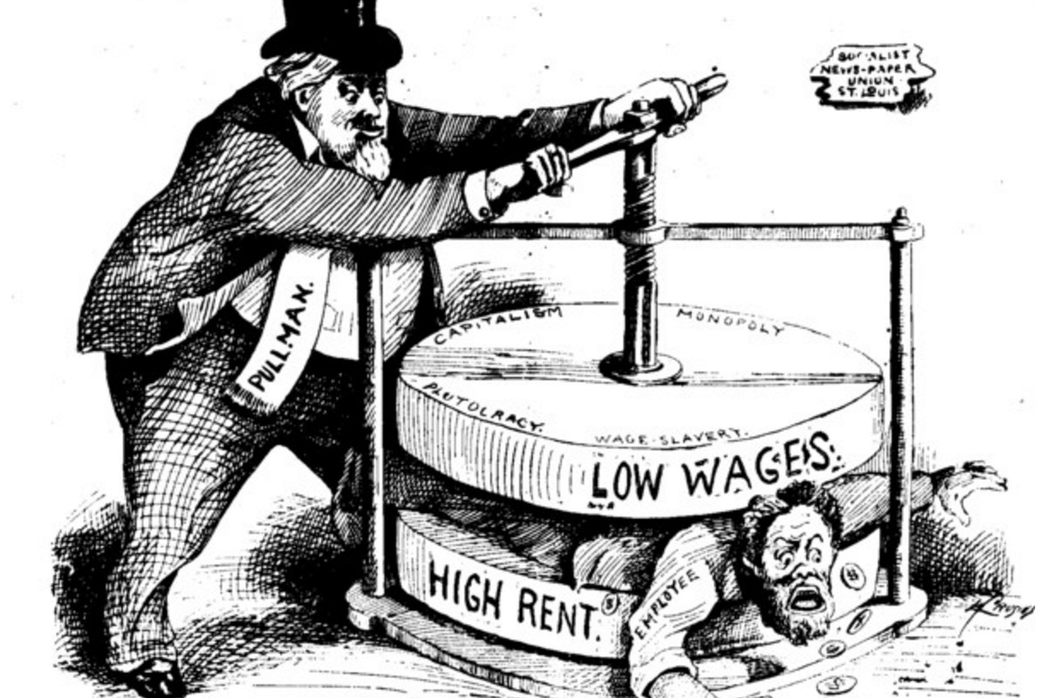

“Throwing Down the Ladder by Which They Rose, by Thomas Nast, 23 July 1870

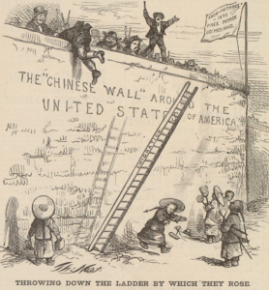

Italian Immigrants at Ellis Island, 1905

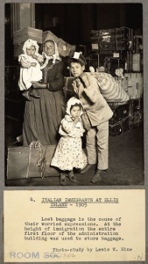

Bosses of the Senate, Joseph Keppler